长水发〔2021〕207号

重庆市长寿区水利局
关于龙溪河（长寿段）环境综合整治与
生态修复亚行贷款项目龙溪河支流（焦家河段）环境综合整治项目洪水影响评价报告的批复

重庆市长寿区城乡统筹开发有限公司：
你司关于龙溪河（长寿段）环境综合整治与生态修复亚行贷款项目龙溪河支流（焦家河段）环境综合整治项目洪水影响评价报告审批申请已收悉，我局组织专家对《龙溪河（长寿段）环境综合整治与生态修复亚行贷款项目龙溪河支流（焦家河段）环境综合整治项目洪水影响评价报告》（送审稿）进行了审查。根据河道管理有关法律法规和专家评审意见，现批复如下：

一、同意龙溪河（长寿段）环境综合整治与生态修复亚行贷款项目龙溪河支流（焦家河段）环境综合整治项目洪水影响评价报告的结论
（一）工程河段属焦家河，工程河段采用10年一遇洪水评价标准，护岸工程采用10年一遇洪水评价标准。
（二）焦家河段治理设施主要由新建护岸工程、清淤工程组成。焦家河治理河段位于邻封镇，上游起于焦家场镇焦家场桥，下游止于河坎湾桥，评价河道中心线总长2749.76m。涉河建筑物布置如下：
1. 防洪护岸工程
左岸堤线长2707.78m，其中新建堤防护岸1780.34m，不治理段927.44m；右岸堤线长2798.14m，其中新建堤防护岸1665.98m，不治理段1132.16m。采用“格宾挡墙+雷诺护坡”型式。
2. 清淤工程
治理河段全线清淤，清淤长度2749.76m，清淤深度0.5m左右。

涉河建筑物控制坐标
（一）左岸堤脚线控制点坐标表
编号 | 桩号 | 坐标值
编号 | 桩号 | X（m） | Y（m）
L1 | JL0+000.00 | 3309496.387 | 417960.199
L2 | JL0+031.41 | 3309475.537 | 417936.709
L3 | JL0+046.42 | 3309469.427 | 417923.249
L4 | JL0+083.85 | 3309464.737 | 417886.109
L5 | JL0+090.14 | 3309464.347 | 417879.839
L6 | JL0+102.90 | 3309464.347 | 417867.079
L7 | JL0+114.80 | 3309462.787 | 417855.319
L8 | JL0+118.89 | 3309461.717 | 417851.369
L9 | JL0+144.14 | 3309448.807 | 417830.059
L10 | JL0+144.30 | 3309448.687 | 417829.939
L11 | JL0+158.91 | 3309435.427 | 417824.639
L12 | JL0+168.29 | 3309426.057 | 417824.489
L13 | JL0+177.02 | 3309417.387 | 417823.519
LU | JL0+232.34 | 3309363.267 | 417812.019
L15 | JL0+257.73 | 3309344.947 | 417796.039
L16 | JL0+269.77 | 3309340.867 | 417784.719
L17 | JL0+270.89 | 3309340.487 | 417783.659
L18 | JL0+272.65 | 3309338.777 | 417783.219
L19 | JL0+276.28 | 3309335.877 | 417781.179
L20 | JL0+316.54 | 3309313.357 | 417747.809
L21 | JL0+340.90 | 3309305.707 | 417724.989
L22 | JL0+358.32 | 3309304.797 | 417707.599
L23 | JL0+370.01 | 3309306.447 | 417696.099
L24 | JL0+383.84 | 3309311.017 | 417683.049
L25 | JL0+394.42 | 3309312.707 | 417672.659
L26 | JL0+403.24 | 3309312.567 | 417663.839
L27 | JL0+414.00 | 3309307.177 | 417655.119
L28 | JL0+419.87 | 3309301.977 | 417652.419
L29 | JL0+442.14 | 3309285.907 | 417661.909
L30 | JL0+448.31 | 3309285.757 | 417668.079
L31 | JL0+459.56 | 3309281.477 | 417678.199
L32 | JL0+483.90 | 3309264.447 | 417695.589
L33 | JL0+500.15 | 3309250.557 | 417703.629
L34 | JL0+502.23 | 3309248.537 | 417704.149
L35 | JL0+517.07 | 3309234.707 | 417700.759
L36 | JL0+520.81 | 3309231.937 | 417698.249
L37 | JL0+537.04 | 3309221.077 | 417686.229
L38 | JL0+571.88 | 3309200.487 | 417658.129
L39 | JL0+589.37 | 3309192.787 | 417642.509
L40 | JL0+603.88 | 3309188.747 | 417628.589
L41 | JL0+644.48 | 3309197.407 | 417590.679
L42 | JL0+709.45 | 3309240.847 | 417542.369
L43 | JL0+774.29 | 3309242.487 | 417482.789
L44 | JL0+785.30 | 3309235.587 | 417474.209
L45 | JL0+820.87 | 3309203.477 | 417468.299
L46 | JL0+872.20 | 3309159.177 | 417494.219
L47 | JL0+920.54 | 3309115.167 | 417487.079
L48 | JL0+956.11 | 3309091.727 | 417460.309
L49 | JL0+984.14 | 3309071.847 | 417440.579
L50 | JL0+994.33 | 3309064.137 | 417433.929
L51 | JL0+013.66 | 3309052.267 | 417418.829
L52 | JL1+032.48 | 3309043.697 | 417402.069
L53 | JL1+075.09 | 3309041.767 | 417360.779
L54 | JL1+087.41 | 3309046.337 | 417349.339
L55 | JL1+097.05 | 3309052.447 | 417342.089
L56 | JL1+098.61 | 3309053.767 | 417341.279
L57 | JL1+120.22 | 3309069.237 | 417326.439
L58 | JL1+124.84 | 3309071.807 | 417322.599
L59 | JL1+143.15 | 3309077.647 | 417305.459
L60 | JL1+150.29 | 3309078.127 | 417298.339
L61 | JL1+164.68 | 3309071.247 | 417286.669
L62 | JL1+173.70 | 3309063.077 | 417282.849
L63 | JL1+217.69 | 3309020.137 | 417278.549
L64 | JL1+224.81 | 3309013.217 | 417280.229
L65 | JL1+235.20 | 3309003.357 | 417283.489
L66 | JL1+266.53 | 3308974.477 | 417295.639
L67 | JL1+295.39 | 3308946.307 | 417300.669
L68 | JL1+325.50 | 3308916.227 | 417299.299
L69 | JL1+367.21 | 3308884.737 | 417275.799
L70 | JL1+435.84 | 3308862.267 | 417210.959
L71 | JL1+503.80 | 3308828.847 | 417152.219
L72 | JL1+506.25 | 3308827.267 | 417150.349
L73 | JL1+551.88 | 3308786.407 | 417134.839
L74 | JL1+585.40 | 3308753.247 | 417139.659
L75 | JL1+641.33 | 3308700.027 | 417127.279
L76 | JL1+711.92 | 3308641.817 | 417087.329
L77 | JL1+729.37 | 3308625.217 | 417086.119
L78 | JL1+731.46 | 3308623.337 | 417087.039
L79 | JL1+767.40 | 3308623.577 | 417115.889
L80 | JL1+774.98 | 3308630.437 | 417119.109
L81 | JL1+785.08 | 3308638.127 | 417125.489
L82 | JL1+797.10 | 3308645.177 | 417135.219
L83 | JL1+809.32 | 3308651.067 | 417145.899
L84 | JL1+830.38 | 3308658.917 | 417165.429
L85 | JL1+837.63 | 3308661.127 | 417172.339
L86 | JL1+857.17 | 3308665.707 | 417191.329
L87 | JL1+884.73 | 3308659.837 | 417217.279
L88 | JL1+887.37 | 3308658.177 | 417219.319
JL89 | JL1+888.87 | 3308657.237 | 417220.489
JL90 | JL1+891.77 | 3308656.487 | 417223.289
JL91 | JL1+930.25 | 3308650.257 | 417261.199
JL92 | JL1+941.49 | 3308649.667 | 417272.419
JL93 | JL1+967.67 | 3308648.637 | 417298.579
JL94 | JL1+982.62 | 3308645.847 | 417313.209
JL95 | JL1+987.74 | 3308644.147 | 417318.049
JL96 | JL2+005.43 | 3308645.927 | 417335.069
JL97 | JL2+008.82 | 3308647.687 | 417337.969
JL98 | JL2+040.34 | 3308650.607 | 417368.299
JL99 | JL2+054.30 | 3308645.757 | 417381.389
JL100 | JL2+088.06 | 3308621.657 | 417403.139
JL101 | JL2+143.75 | 3308567.717 | 417417.009
JL102 | JL2+160.26 | 3308551.317 | 417418.399
JL103 | JL2+172.31 | 3308539.287 | 417417.809
JL104 | JL2+195.89 | 3308521.297 | 417404.669
JL105 | JL2+259.05 | 3308499.127 | 417345.529
JL106 | JL2+283.17 | 3308495.237 | 417321.889
JL107 | JL2+283.39 | 3308495.247 | 417321.659
JL108 | JL2+330.31 | 3308485.927 | 417276.119
JL109 | JL2+352.33 | 3308476.617 | 417256.159
JL110 | JL2+372.82 | 3308460.237 | 417245.769
JL111 | JL2+443.30 | 3308389.757 | 417246.009
JL112 | JL2+497.12 | 3308336.717 | 417253.949
JL113 | JL2+518.85 | 3308315.917 | 417260.239
JL114 | JL2+550.72 | 3308295.537 | 417282.719
JL115 | JL2+560.16 | 3308293.707 | 417291.989
JL116 | JL2+633.25 | 3308314.477 | 417358.959
JL117 | JL2+673.22 | 3308343.077 | 417386.889
JL118 | JL2+705.79 | 3308355.987 | 417415.949
JL119 | JL2+707.78 | 3308356.067 | 417417.929

（二）右岸堤脚线控制点坐标表
编号 | 桩号 | 坐标值
编号 | 桩号 | X（m） | Y（m）
R1 | JR0+000.00 | 3309505.057 | 417954.549
R2 | JR0+021.15 | 3309492.307 | 417937.679
R3 | JR0+053.14 | 3309480.557 | 417908.319
R4 | JR0+060.64 | 3309479.707 | 417900.879
R5 | JR0+066.45 | 3309478.227 | 417895.279
R6 | JR0+066.90 | 3309478.047 | 417894.859
R7 | JR0+092.87 | 3309472.797 | 417869.609
R8 | JR0+105.63 | 3309472.727 | 417856.839
R9 | JR0+126.94 | 3309468.147 | 417836.199
R10 | JR0+143.46 | 3309461.247 | 417821.199
R11 | JR0+152.27 | 3309454.277 | 417816.549
R12 | JR0+169.96 | 3309436.607 | 417815.879
R13 | JR0+184.23 | 3309422.837 | 417812.479
R14 | JR0+198.82 | 3309409.687 | 417806.189
R15 | JR0+208.21 | 3309400.767 | 417803.319
R16 | JR0+228.44 | 3309380.857 | 417799.749
R17 | JR0+259.39 | 3309354.537 | 417784.639
R18 | JR0+264.74 | 3309351.077 | 417780.579
R19 | JR0+270.68 | 3309349.917 | 417774.749
R20 | JR0+278.51 | 3309346.497 | 417767.799
R21 | JR0+293.05 | 3309336.927 | 417756.859
R22 | JR0+361.41 | 3309321.937 | 417692.909
R23 | JR0+384.14 | 3309327.737 | 417670.939
R24 | JR0+456.51 | 3309281.317 | 417646.259
R25 | JR0+466.61 | 3309274.667 | 417653.849
R26 | JR0+476.63 | 3309268.857 | 417662.009
R27 | JR0+500.62 | 3309256.957 | 417682.839
R28 | JR0+510.10 | 3309248.747 | 417685.589
R29 | JR0+519.56 | 3309240.057 | 417681.849
R30 | JR0+535.11 | 3309227.957 | 417672.359
R31 | JR0+564.40 | 3309210.307 | 417648.989
R32 | JR0+624.56 | 3309213.687 | 417593.829
R33 | JR0+692.54 | 3309262.487 | 417546.499
R34 | JR0+747.83 | 3309269.787 | 417495.639
R35 | JR0+779.52 | 3309254.167 | 417468.069
R36 | JR0+844.29 | 3309197.967 | 417451.659
R37 | JR0+898.91 | 3309149.707 | 417477.219
R38 | JR0+917.36 | 3309132.537 | 417474.999
R39 | JR0+995.51 | 3309074.997 | 417422.129
R40 | JR1+017.70 | 3309062.457 | 417404.019
R41 | JR1+035.02 | 3309055.977 | 417387.969
R42 | JR1+072.50 | 3309064.357 | 417353.889
R43 | JR1+084.62 | 3309073.587 | 417346.039
R44 | JR1+093.40 | 3309079.347 | 417339.459
R45 | JR1+130.44 | 3309099.437 | 417308.339
R46 | JR1+143.92 | 3309105.967 | 417296.559
R47 | JR1+161.01 | 3309113.217 | 417281.079
R48 | JR1+172.83 | 3309104.897 | 417272.679
R49 | JR1+182.20 | 3309096.547 | 417273.919
R50 | JR1+193.91 | 3309087.107 | 417266.979
R51 | JR1+203.78 | 3309078.807 | 417261.639
R52 | JR1+273.32 | 3309011.637 | 417256.549
R53 | JR1+318.52 | 3308969.317 | 417272.429
R54 | JR1+345.53 | 3308942.807 | 417276.469
R55 | JR1+352.60 | 3308935.747 | 417276.069
R56 | JR1+397.49 | 3308901.987 | 417250.549
R57 | JR1+464.88 | 3308879.967 | 417186.859
R58 | JR1+527.34 | 3308848.027 | 417133.709
R59 | JR1+547.48 | 3308834.307 | 417118.959
R60 | JR1+573.79 | 3308811.117 | 417107.889
R61 | JR1+632.35 | 3308752.707 | 417103.809
R62 | JR1+645.75 | 3308739.617 | 417101.099
R63 | JR1+687.78 | 3308699.967 | 417087.169
R64 | JR1+714.30 | 3308676.397 | 417075.189
R65 | JR1+730.09 | 3308663.387 | 417066.229
R66 | JR1+766.12 | 3308628.967 | 417060.929
R67 | JR1+782.95 | 3308612.877 | 417065.869
R68 | JR1+816.32 | 3308591.107 | 417089.159
R69 | JR1+832.83 | 3308587.337 | 417105.229
R70 | JR1+867.04 | 3308601.187 | 417133.629
R71 | JR1+880.66 | 3308613.557 | 417139.349
R72 | R1+924.35 | 3308639.057 | 417172.709
R73 | JR1+938.01 | 3308641.327 | 417186.179
R74 | JR1+954.77 | 3308641.007 | 417202.849
R75 | JR1+967.85 | 3308638.347 | 417215.649
JR76 | JR1+971.75 | 3308641.817 | 417219.109
JR77 | JR2+018.67 | 3308638.227 | 417265.889
JR78 | JR2+039.48 | 3308634.497 | 417286.319
JR79 | JR2+056.03 | 3308629.847 | 417302.209
JR80 | JR2+078.24 | 3308619.957 | 417321.959
JR81 | JR2+088.84 | 3308613.587 | 417330.439
JR82 | JR2+114.96 | 3308616.397 | 417353.919
JR83 | JR2+130.09 | 3308628.087 | 417363.519
JR84 | JR2+162.37 | 3308623.027 | 417389.439
JR85 | JR2+191.95 | 3308594.777 | 417398.219
JR86 | JR2+211.17 | 3308576.177 | 417403.039
JR87 | JR2+238.26 | 3308549.657 | 417408.569
JR88 | JR2+266.88 | 3308526.757 | 417395.769
JR89 | JR2+32L39 | 3308508.287 | 417344.479
JR90 | JR2+331.41 | 3308506.287 | 417334.699
JR91 | JR2+357.18 | 3308504.757 | 417308.979
JR92 | JR2+407.08 | 3308489.737 | 417261.929
JR93 | JR2+426.36 | 3308479.517 | 417245.579
JR94 | JR2+440.01 | 3308468.327 | 417238.609
JR95 | JR2+492.92 | 3308415.547 | 417234.959
JR96 | JR2+571.76 | 3308337.247 | 417241.229
JR97 | JR2+583.58 | 3308325.727 | 417243.909
JR98 | JR2+658.49 | 3308281.847 | 417297.929
JR99 | JR2+661.01 | 3308281.797 | 417300.449
JR100 | JR2+743.41 | 3308313.097 | 417373.999
JR101 | JR2+769.99 | 3308332.667 | 417391.999
JR102 | JR2+793.62 | 3308344.027 | 417412.269
JR103 | JR2+798.14 | 3308344.897 | 417416.699
注：项目控制点采用2000国家大地坐标系及1985国家高程基准。

二、有关要求
（一）你司应严格按照批复的内容和要求实施，自觉接受我局的监督管理。
（二）你司应充分重视河道保护工作，严禁向河道内倾倒弃土弃渣，并及时清除河道管理范围内的施工临时设施，保障河道行洪通畅。
（三）工程开工前，项目业主应将施工安排报送我局备案。我局将对涉河建设项目在施工过程中和竣工后的界线坐标、规模尺寸、高程、边坡等实施情况进行全面复核。
（四）加强施工期的管理，督促施工单位编制工程度汛方案及措施，并报项目业主及主管部门备案。
（五）工程施工完毕，业主及时向区水利局提交竣工验收鉴定书，竣工验收时，应邀请我局参加。
（六）本批复有效期为三年，自签发之日起计算。期满后，若该工程未开工建设，本批复自行失效；若需延续有效期，应在有效期届满三十日前提出延续申请。工程建设过程中涉河建设方案有较大变更的，也应按规定重新办理审批手续。

附件：龙溪河（长寿段）环境综合整治与生态修复亚行贷款项目龙溪河支流（焦家河段）环境综合整治项目洪水影响评价报告专家评审意见

重庆市长寿区水利局
2021年9月22日

附件
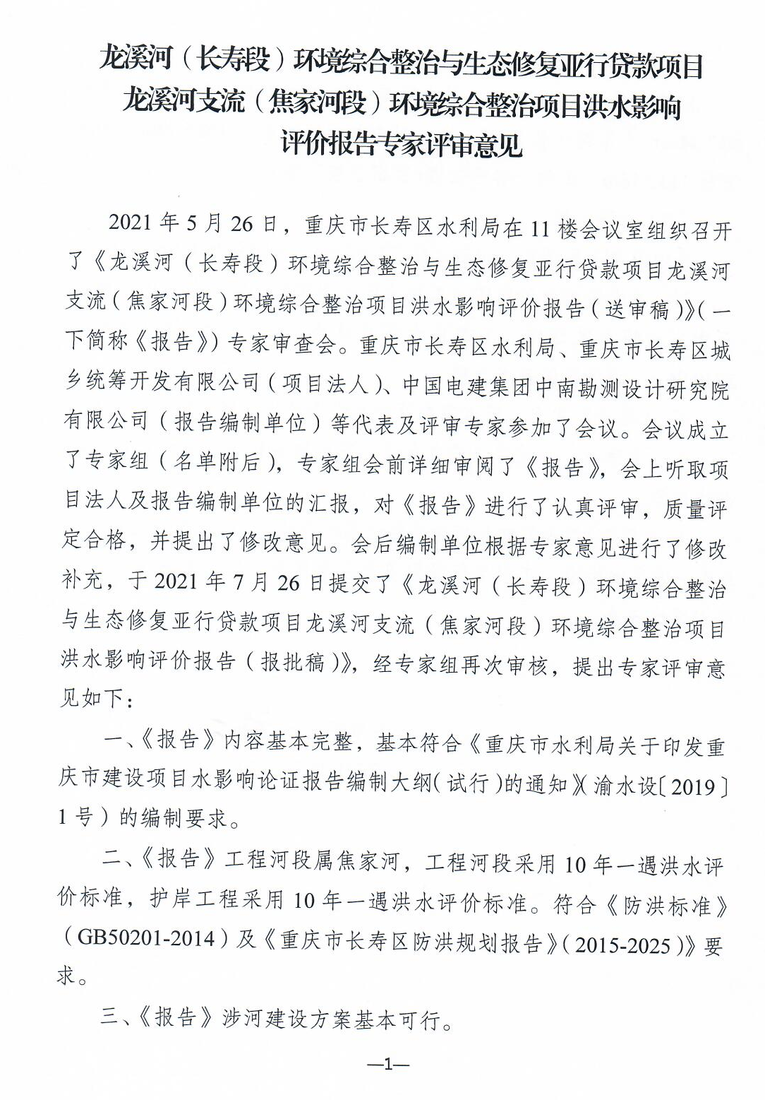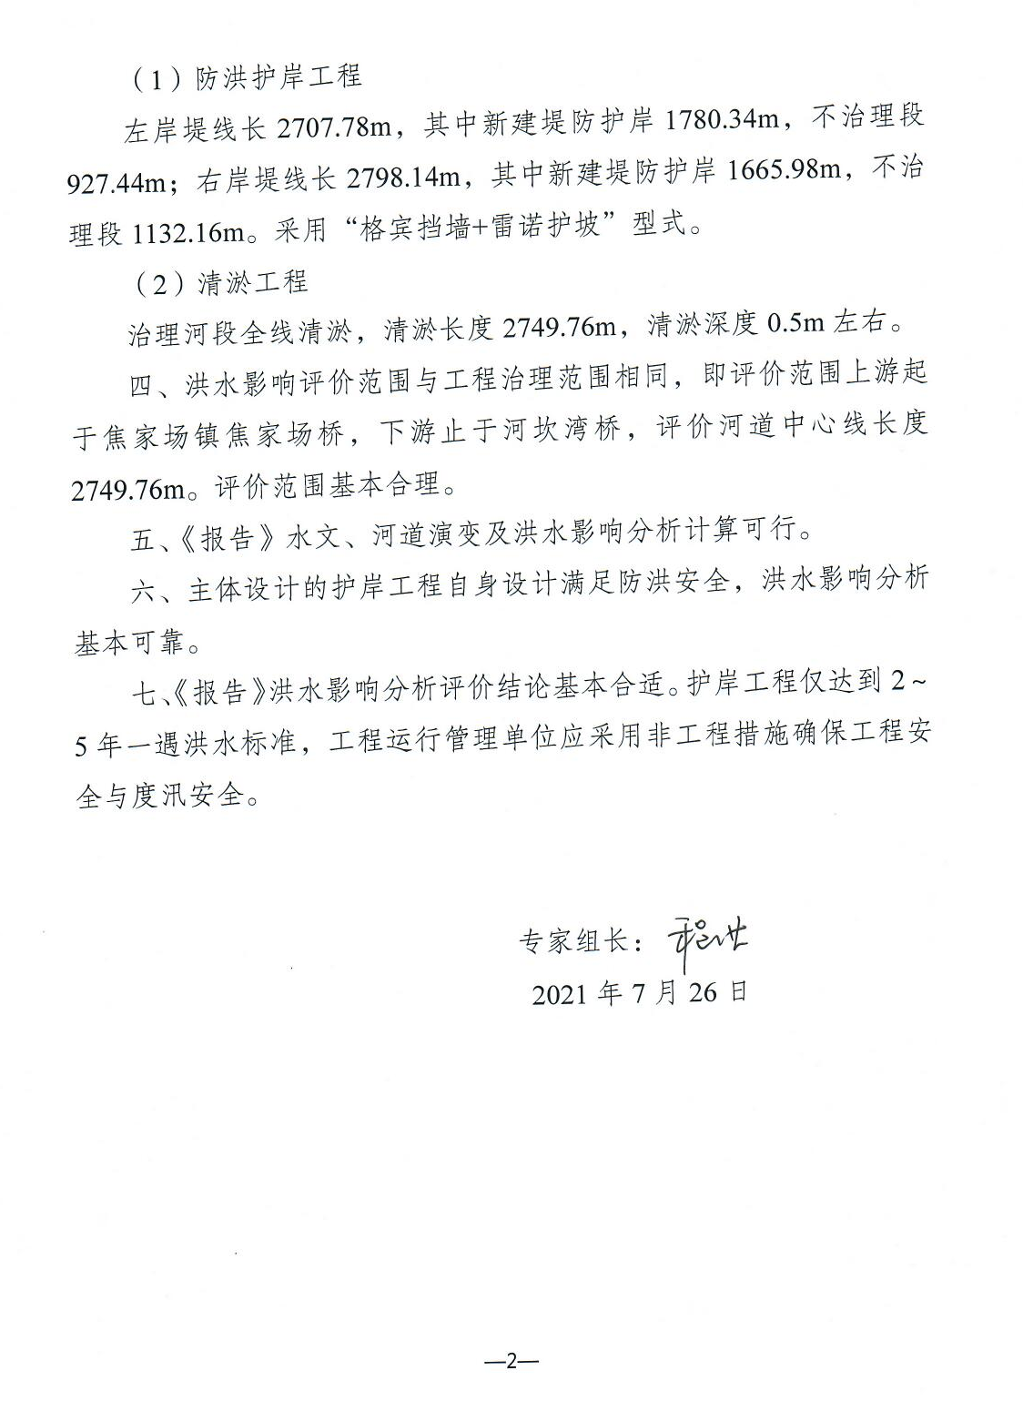

重庆市长寿区水利局办公室 2021年9月22日印发

