长水发〔2021〕205号

重庆市长寿区水利局
关于龙溪河（长寿段）环境综合整治与
生态修复亚行贷款项目龙溪河支流（双龙河段）环境综合整治项目洪水影响评价报告的批复

重庆市长寿区城乡统筹开发有限公司：
你司关于龙溪河（长寿段）环境综合整治与生态修复亚行贷款项目龙溪河支流（双龙河段）环境综合整治项目洪水影响评价报告审批申请已收悉，我局组织专家对《龙溪河（长寿段）环境综合整治与生态修复亚行贷款项目龙溪河支流（双龙河段）环境综合整治项目洪水影响评价报告》（送审稿）进行了审查。根据河道管理有关法律法规和专家评审意见，现批复如下：

一、同意龙溪河（长寿段）环境综合整治与生态修复亚行贷款项目龙溪河支流（双龙河段）环境综合整治项目洪水影响评价报告的结论
（一）工程河段属双龙河及其支流王家沟，双龙河河段采用10年一遇洪水评价标准，王家沟分洪渠箱涵部分满足50年一遇洪水评价标准，分洪渠其他部分满足20年一遇设计评价标准、50年一遇校核评价标准。
（二）该工程上游起于双龙镇林家坝桥下游约140m处，下游止于老娃咀堰，治理河道长11869.08m。新建防洪护岸22801.34m，河道清淤11869.08m，27处排水涵管，54处下河梯步，21583m两岸人行步道以及1处王家沟分洪工程。涉河建筑物布置如下：
1. 防洪护岸工程
左岸岸线长度11796.22m，新建护防岸长度11284.50m；右岸岸线长度11750.75m，新建护岸长度11516.84m，河道清淤长度11869.08m。主要采取“格宾挡墙+雷诺护坡”型式。附属设施包括27处排水涵管，54处下河梯步，21583.00m两岸人行步道等。
2. 王家沟分洪工程
由引水渠、分洪渠组成。引水渠最大过流能力12.70m³/s，渠长174.0m，过流宽度6.0m，底坡i=0.01，采用0.5m厚C20钢筋砼结构引水渠底板，采用C20砼重力式边墙；分洪渠总长344.86m，设计分洪流量15.00m³/s，从进口至出口依次由侧堰控制段、平底坡调整段、泄槽明渠段Ⅰ、公路涵洞段、泄槽箱涵段、泄槽明渠段Ⅱ和消力池组成。

涉河建筑物控制坐标
（一）左岸堤脚线控制点坐标表
编号 | 桩号 | 坐标值 |  | 编号 | 桩号 | 坐标值
编号 | 桩号 | X | Y | 编号 | 桩号 | X | Y
SL1 | SL0+000.00 | 3316556.39 | 423396.7423 | SL140 | SL5+931.27 | 3318475.55 | 424703.9523
SL2 | SL0+041.95 | 3316596.3 | 423409.7123 | SL141 | SL5+956.59 | 3318496.55 | 424696.9623
SL3 | SL0+058.80 | 3316608.74 | 423401.7823 | SL142 | SL5+984.56 | 3318506.49 | 424670.8123
SL4 | SL0+065.96 | 3316609.61 | 423394.6823 | SL143 | SL6+030.67 | 3318540.61 | 424673.8223
SL5 | SL0+079.68 | 3316618.77 | 423385.9423 | SL144 | SL6+057.86 | 3318545.68 | 424700.5423
SL6 | SL0+131.40 | 3316670.35 | 423382.0523 | SL145 | SL6+103.92 | 3318550.86 | 424746.2623
SL7 | SL0+158.67 | 3316687.39 | 423399.0123 | SL146 | SL6+123.07 | 3318551.59 | 424765.4023
SL8 | SL0+202.53 | 3316684.28 | 423442.7723 | SL147 | SL6+167.92 | 3318537.82 | 424807.0923
SL9 | SL0+255.12 | 3316646.53 | 423468.7023 | SL148 | SL6+231.65 | 3318497.93 | 424856.7823
SL10 | SL0+293.87 | 3316609.47 | 423457.4023 | SL149 | SL6+270.95 | 3318498.78 | 424892.9423
SL11 | SL0+310.91 | 3316592.65 | 423455.2023 | SL150 | SL6+338.85 | 3318543.74 | 424943.8223
SL12 | SL0+317.44 | 3316586.12 | 423455.4323 | SL151 | SL6+384.03 | 3318559.31 | 424985.1823
SL13 | SL0+346.16 | 3316573.77 | 423476.2223 | SL152 | SL6+426.96 | 3318559.16 | 425028.1123
SL14 | SL0+357.69 | 3316578.92 | 423486.5323 | SL153 | SL6+469.81 | 3318589.01 | 425049.2623
SL15 | SL0+394.89 | 3316604.53 | 423512.6923 | SL154 | SL6+497.17 | 3318614.79 | 425040.1023
SL16 | SL0+440.43 | 3316644.83 | 423533.8823 | SL155 | SL6+584.86 | 3318688.53 | 425070.9723
SL17 | SL0+484.98 | 3316681.1 | 423559.5323 | SL156 | SL6+619.01 | 3318702.96 | 425101.9223
SL18 | SL0+489.93 | 3316684.73 | 423562.9023 | SL157 | SL6+650.87 | 3318710.81 | 425132.6223
SL19 | SL0+534.36 | 3316726.11 | 423569.6023 | SL158 | SL6+684.64 | 3318712.98 | 425166.3123
SL20 | SL0+587.88 | 3316774.85 | 423547.4923 | SL159 | SL6+738.29 | 3318748.41 | 425199.8423
SL21 | SL0+647.12 | 3316832.29 | 423547.7023 | SL160 | SL6+769.74 | 3318779.86 | 425200.1223
SL22 | SL0+665.86 | 3316849.3 | 423555.5723 | SL161 | SL6+834.20 | 3318844.05 | 425205.2823
SL23 | SL0+703.56 | 3316873.57 | 423583.0123 | SL162 | SL6+869.57 | 3318879.03 | 425210.6123
SL24 | SL0+725.04 | 3316880.13 | 423603.4623 | SL163 | SL6+940.65 | 3318949.85 | 425211.0023
SL25 | SL0+766.58 | 3316913.13 | 423621.7123 | SL164 | SL6+959.77 | 3318968.78 | 425208.3323
SL26 | SL0+803.20 | 3316948.62 | 423612.6623 | SL165 | SL6+987.08 | 3318995.63 | 425211.4123
SL27 | SL0+846.76 | 3316971.66 | 423579.9523 | SL166 | SL7+016.77 | 3319016.88 | 425231.1223
SL28 | SL0+900.69 | 3316966.64 | 423526.2623 | SL167 | SL7+045.87 | 3319029.07 | 425257.5423
SL29 | SL0+943.19 | 3316982.93 | 423488.9323 | SL168 | SL7+076.15 | 3319035.87 | 425286.8323
SL30 | SL0+955.76 | 3316992.9 | 423481.2923 | SL169 | SL7+081.72 | 3319036 | 425292.4023
SL31 | SL1+040.66 | 3317072.98 | 423461.1623 | SL170 | SL7+115.69 | 3319047.15 | 425323.8923
SL32 | SL1+108.74 | 3317140.17 | 423472.1323 | SL171 | SL7+128.55 | 3319055 | 425334.0723
SL33 | SL1+155.16 | 3317180.75 | 423493.0523 | SL172 | SL7+136.04 | 3319057.56 | 425340.9923
SL34 | SL1+455.63 | 3317392.27 | 423706.4723 | SL173 | SL7+138.12 | 3319057.66 | 425343.0723
SL35 | SL1+552.54 | 3317449.27 | 423667.9523 | SL174 | SL7+141.45 | 3319059.13 | 425345.9523
SL36 | SL1+727.95 | 3317379.76 | 423506.9023 | SL175 | SL7+145.71 | 3319062.45 | 425348.6223
SL37 | SL1+807.68 | 3317425.32 | 423467.9423 | SL176 | SL7+156.78 | 3319069.08 | 425339.7523
SL38 | SL1+841.36 | 3317453.8 | 423485.9223 | SL177 | SL7+167.35 | 3319076.6 | 425332.3223
SL39 | SL1+876.02 | 3317483.95 | 423502.9823 | SL178 | SL7+178.75 | 3319086.66 | 425327.1623
SL40 | SL1+931.54 | 3317533.53 | 423527.9523 | SL179 | SL7+359.79 | 3319261.44 | 425279.9623
SL41 | SL1+979.51 | 3317564.72 | 423504.8523 | SL180 | SL7+383.54 | 3319284.74 | 425281.3723
SL42 | SL2+019.81 | 3317557.88 | 423465.1423 | SL181 | SL7+407.87 | 3319307.29 | 425290.5023
SL43 | SL2+099.91 | 3317585.58 | 423394.1123 | SL182 | SL7+434.08 | 3319332.94 | 425294.7023
SL44 | SL2+139.19 | 3317616.69 | 423370.1423 | SL183 | SL7+494.10 | 3319392.86 | 425291.1223
SL45 | SL2+149.14 | 3317622.17 | 423362.0523 | SL184 | SL7+543.34 | 3319442.07 | 425291.1823
SL46 | SL2+150.56 | 3317622.56 | 423360.6823 | SL185 | SL7+548.40 | 3319447.12 | 425291.5023
SL47 | SL2+172.96 | 3317640.36 | 423351.6823 | SL186 | SL7+618.86 | 3319517.55 | 425293.1823
SL48 | SL2+180.00 | 3317646.96 | 423354.1523 | SL187 | SL7+640.91 | 3319539.59 | 425292.8623
SL49 | SL2+190.93 | 3317657.37 | 423352.8023 | SL188 | SL7+687.71 | 3319576.4 | 425317.0923
SL50 | SL2+203.81 | 3317667.88 | 423345.3523 | SL189 | SL7+741.83 | 3319597.06 | 425367.1123
SL51 | SL2+230.20 | 3317685.06 | 423325.6423 | SL190 | SL7+787.82 | 3319625.87 | 425357.2823
SL52 | SL2+245.97 | 3317692.33 | 423311.6523 | SL191 | SL7+802.25 | 3319622.08 | 425343.3523
SL53 | SL2+283.18 | 3317718.08 | 423285.5623 | SL192 | SL7+810.19 | 3319629.81 | 425341.5423
SL54 | SL2+341.64 | 3317769.59 | 423257.9223 | SL193 | SL7+817.07 | 3319631.64 | 425348.1623
SL55 | SL2+410.05 | 3317835.16 | 423240.7923 | SL194 | SL7+848.73 | 3319656.94 | 425354.2923
SL56 | SL2+424.42 | 3317849.53 | 423240.5323 | SL195 | SL7+873.41 | 3319673.67 | 425336.1523
SL57 | SL2+479.69 | 3317894.84 | 423267.1123 | SL196 | SL7+912.57 | 3319707.63 | 425318.1723
SL58 | SL2+502.73 | 3317905.7 | 423287.4323 | SL197 | SL7+923.81 | 3319718.75 | 425316.5123
SL59 | SL2+577.43 | 3317892.97 | 423355.3923 | SL198 | SL7+938.53 | 3319732 | 425310.5423
SL60 | SL2+601.81 | 3317874.47 | 423371.2723 | SL199 | SL7+948.42 | 3319739.57 | 425304.1823
SL61 | SL2+626.85 | 3317851.12 | 423377.7923 | SL200 | SL7+961.66 | 3319751.4 | 425298.5423
SL62 | SL2+642.82 | 3317835.36 | 423375.1723 | SL201 | SL7+986.13 | 3319775.42 | 425293.9023
SL63 | SL2+661.26 | 3317817.26 | 423377.1923 | SL202 | SL8+007.61 | 3319795.04 | 425285.5523
SL64 | SL2+730.93 | 3317752.74 | 423403.4623 | SL203 | SL8+216.32 | 3319965.71 | 425165.4123
SL65 | SL2+759.34 | 3317738 | 423425.7723 | SL204 | SL8+275.12 | 3320022.37 | 425157.2323
SL66 | SL2+786.84 | 3317738.45 | 423453.2623 | SL205 | SL8+379.61 | 3320122.73 | 425186.3223
SL67 | SL2+807.39 | 3317735.82 | 423473.5723 | SL206 | SL8+504.80 | 3320199.47 | 425276.2623
SL68 | SL2+849.25 | 3317723.81 | 423513.6723 | SL207 | SL8+541.12 | 3320203.97 | 425312.3023
SL69 | SL2+877.45 | 3317722.31 | 423541.5623 | SL208 | SL8+678.77 | 3320150.18 | 425431.6223
SL70 | SL2+923.17 | 3317730.64 | 423586.5223 | SL209 | SL8+715.14 | 3320120.16 | 425452.1523
SL71 | SL2+953.25 | 3317754.06 | 423594.0523 | SL210 | SL8+789.40 | 3320050.84 | 425476.2323
SL72 | SL3+000.53 | 3317788.16 | 423561.2923 | SL211 | SL8+810.40 | 3320029.89 | 425477.6723
SL73 | SL3+053.52 | 3317834.76 | 423565.4023 | SL212 | SL8+840.93 | 3320002.42 | 425489.5923
SL74 | SL3+075.79 | 3317847.87 | 423583.4123 | SL213 | SL8+933.27 | 3319934.83 | 425552.5123
SL75 | SL3+095.24 | 3317856.85 | 423600.5723 | SL214 | SL9+000.71 | 3319920.22 | 425614.4023
SL76 | SL3+198.63 | 3317890.74 | 423698.2523 | SL215 | SL9+012.52 | 3319924.35 | 425625.4723
SL77 | SL3+228.64 | 3317911.63 | 423718.2323 | SL216 | SL9+095.40 | 3319978.81 | 425685.2723
SL78 | SL3+302.15 | 3317982.09 | 423739.1923 | SL217 | SL9+122.24 | 3320002.97 | 425696.9723
SL79 | SL3+327.48 | 3318004.34 | 423750.9523 | SL218 | SL9+131.40 | 3320007.22 | 425705.0923
SL80 | SL3+348.60 | 3318020.71 | 423764.2823 | SL219 | SL9+150.52 | 3320023.08 | 425715.7723
SL81 | SL3+370.64 | 3318041.35 | 423770.0523 | SL220 | SL9+277.24 | 3320101.77 | 425812.7323
SL82 | SL3+403.59 | 3318073.99 | 423765.5123 | SL221 | SL9+496.03 | 3320184.02 | 426015.4723
SL83 | SL3+480.09 | 3318138.98 | 423728.6923 | SL222 | SL9+539.30 | 3320184.36 | 426057.7223
SL84 | SL3+577.87 | 3318200.33 | 423652.5623 | SL223 | SL9+541.48 | 3320183.57 | 426059.7523
SL85 | SL3+599.60 | 3318209.52 | 423633.0823 | SL224 | SL9+577.05 | 3320188.78 | 426093.3223
SL86 | SL3+670.69 | 3318223.88 | 423563.4623 | SL225 | SL9+650.62 | 3320234.88 | 426150.6523
SL87 | SL3+694.14 | 3318226.26 | 423540.1723 | SL226 | SL9+704.25 | 3320283.14 | 426165.7423
SL88 | SL3+737.57 | 3318226.26 | 423496.7423 | SL227 | SL9+747.18 | 3320324.31 | 426153.5623
SL89 | SL3+801.58 | 3318246.77 | 423437.3423 | SL228 | SL9+772.35 | 3320349.22 | 426151.7723
SL90 | SL4+000.74 | 3318369.64 | 423280.6123 | SL229 | SL9+788.38 | 3320365.09 | 426154.0623
SL91 | SL4+064.57 | 3318404.77 | 423227.4023 | SL230 | SL9+844.08 | 3320417.66 | 426171.5623
SL92 | SL4+079.37 | 3318411.9 | 423214.4323 | SL231 | SL9+844.78 | 3320418.27 | 426171.8923
SL93 | SL4+100.46 | 3318416.75 | 423194.1723 | SL232 | SL9+883.08 | 3320437.05 | 426203.2123
SL94 | SL4+105.52 | 3318421.69 | 423193.1023 | SL233 | SL9+958.33 | 3320437.67 | 426278.4623
SL95 | SL4+166.24 | 3318451.18 | 423244.4223 | SL234 | SL10+010.25 | 3320429.54 | 426329.5023
SL96 | SL4+185.26 | 3318466.23 | 423256.0523 | SL235 | SL10+043.53 | 3320418.94 | 426361.0523
SL97 | SL4+303.09 | 3318513.76 | 423358.9523 | SL236 | SL10+090.21 | 3320407.44 | 426406.2523
SL98 | SL4+334.54 | 3318512.27 | 423390.3723 | SL237 | SL10+117.76 | 3320402.67 | 426433.3823
SL99 | SL4+370.90 | 3318504.6 | 423425.7423 | SL238 | SL10+160.85 | 3320423.35 | 426466.9123
SL100 | SL4+472.85 | 3318464.15 | 423519.3223 | SL239 | SL10+175.38 | 3320437.26 | 426471.0823
SL101 | SL4+506.35 | 3318469.32 | 423550.6023 | SL240 | SL10+215.39 | 3320468.95 | 426494.2523
SL102 | SL4+642.03 | 3318560.36 | 423651.2023 | SL241 | SL10+265.97 | 3320497.49 | 426536.0123
SL103 | SL4+688.54 | 3318558.96 | 423693.2423 | SL242 | SL10+309.51 | 3320535.73 | 426550.4923
SL104 | SL4+711.89 | 3318542.18 | 423709.4823 | SL243 | SL10+384.31 | 3320608.25 | 426532.1923
SL105 | SL4+724.07 | 3318530.08 | 423708.0323 | SL244 | SL10+417.34 | 3320640.9 | 426532.6623
SL106 | SL4+743.31 | 3318512.27 | 423715.3023 | SL245 | SL10+437.87 | 3320652.85 | 426547.7323
SL107 | SL4+764.08 | 3318495.72 | 423727.4923 | SL246 | SL10+522.31 | 3320632.74 | 426628.7123
SL108 | SL4+769.45 | 3318492.3 | 423731.6423 | SL247 | SL10+550.77 | 3320616.4 | 426651.8723
SL109 | SL4+800.34 | 3318477.76 | 423758.6623 | SL248 | SL10+577.52 | 3320597.71 | 426671.0123
SL110 | SL4+865.28 | 3318458.62 | 423820.7223 | SL249 | SL10+620.69 | 3320602.62 | 426708.2023
SL111 | SL4+887.30 | 3318456.44 | 423842.4923 | SL250 | SL10+638.21 | 3320617.7 | 426717.1323
SL112 | SL4+897.07 | 3318457.4 | 423852.2123 | SL251 | SL10+676.48 | 3320638.6 | 426747.7323
SL113 | SL4+911.92 | 3318454.28 | 423866.4723 | SL252 | SL10+764.69 | 3320652.84 | 426834.7923
SL114 | SL4+922.43 | 3318448.96 | 423875.5423 | SL253 | SL10+819.46 | 3320680.24 | 426880.7223
SL115 | SL4+930.48 | 3318445.99 | 423882.9923 | SL254 | SL10+866.97 | 3320717.86 | 426909.7523
SL116 | SL4+985.37 | 3318433.62 | 423936.4723 | SL255 | SL10+876.77 | 3320724.11 | 426917.1923
SL117 | SL5+035.86 | 3318410.93 | 423981.0123 | SL256 | SL10+882.44 | 3320726.75 | 426922.2123
SL118 | SL5+063.76 | 3318392.63 | 424002.0823 | SL257 | SL10+890.59 | 3320732.36 | 426927.9623
SL119 | SL5+093.74 | 3318381.15 | 424029.2423 | SL258 | SL10+956.62 | 3320790.09 | 426960.0123
SL120 | SL5+121.60 | 3318378.78 | 424056.9923 | SL259 | SL11+010.38 | 3320808.76 | 427006.0923
SL121 | SL5+148.20 | 3318378.07 | 424083.5723 | SL260 | SL11+035.28 | 3320801.53 | 427029.9223
SL122 | SL5+168.02 | 3318378.69 | 424103.3823 | SL261 | SL11+064.48 | 3320786.85 | 427054.8523
SL123 | SL5+235.39 | 3318358.49 | 424166.2923 | SL262 | SL11+071.73 | 3320781.8 | 427060.0523
SL124 | SL5+265.67 | 3318340.11 | 424190.3423 | SL263 | SL11+125.08 | 3320749.32 | 427102.2323
SL125 | SL5+320.84 | 3318342.1 | 424241.1823 | SL264 | SL11+308.43 | 3320654.72 | 427259.2923
SL126 | SL5+327.26 | 3318346.38 | 424245.9623 | SL265 | SL11+344.85 | 3320658.06 | 427293.1123
SL127 | SL5+383.18 | 3318394.13 | 424273.1923 | SL266 | SL11+354.62 | 3320664.65 | 427300.3323
SL128 | SL5+403.33 | 3318413.89 | 424277.1223 | SL267 | SL11+359.81 | 3320661.09 | 427304.1123
SL129 | SL5+442.18 | 3318447.14 | 424295.9323 | SL268 | SL11+379.06 | 3320663.04 | 427323.2623
SL130 | SL5+460.68 | 3318459.58 | 424309.6223 | SL269 | SL11+426.99 | 3320673.05 | 427370.0423
SL131 | SL5+588.66 | 3318423.56 | 424407.2523 | SL270 | SL11+468.66 | 3320686.17 | 427409.5923
SL132 | SL5+600.78 | 3318411.54 | 424408.7723 | SL271 | SL11+510.51 | 3320689.15 | 427450.9023
SL133 | SL5+615.25 | 3318400.85 | 424417.4123 | SL272 | SL11+547.58 | 3320682.65 | 427487.4023
SL134 | SL5+676.37 | 3318380.57 | 424475.0623 | SL273 | SL11+598.65 | 3320682.53 | 427538.2123
SL135 | SL5+704.77 | 3318379.05 | 424503.0523 | SL274 | SL11+653.68 | 3320691.94 | 427592.4323
SL136 | SL5+765.01 | 3318392.79 | 424561.6923 | SL275 | SL11+695.90 | 3320724.06 | 427610.7023
SL137 | SL5+802.27 | 3318406.41 | 424596.2323 | SL276 | SL11+729.74 | 3320755.68 | 427598.6223
SL138 | SL5+908.02 | 3318459.09 | 424687.9323 | SL277 | SL11+766.30 | 3320791.56 | 427597.4123
SL139 | SL5+927.91 | 3318472.71 | 424702.1523 | SL278 | SL11+796.22 | 3320820.17 | 427606.1723

（二）右岸堤脚线控制点坐标表
编号 | 桩号 | 坐标值 |  | 编号 | 桩号 | 坐标值
编号 | 桩号 | X | Y | 编号 | 桩号 | X | Y
SR1 | SR0+000.00 | 3316553.51 | 423406.8823 | SR143 | SR5+941.39 | 3318508.41 | 424712.4823
SR2 | SR0+043.49 | 3316594.73 | 423420.7223 | SR144 | SR5+976.31 | 3318534.22 | 424726.3623
SR3 | SR0+073.10 | 3316616.35 | 423406.6923 | SR145 | SR6+008.66 | 3318536.47 | 424758.6323
SR4 | SR0+076.08 | 3316616.63 | 423403.7223 | SR146 | SR6+057.31 | 3318521.29 | 424803.5323
SR5 | SR0+088.11 | 3316624.66 | 423396.1823 | SR147 | SR6+108.26 | 3318487.63 | 424841.7723
SR6 | SR0+135.11 | 3316671.63 | 423394.6223 | SR148 | SR6+175.45 | 3318488.22 | 424903.1223
SR7 | SR0+143.12 | 3316676.49 | 423399.8423 | SR149 | SR6+194.53 | 3318501.1 | 424917.2023
SR8 | SR0+182.73 | 3316673.39 | 423439.3323 | SR150 | SR6+226.87 | 3318521.71 | 424942.1123
SR9 | SR0+219.30 | 3316647 | 423457.1323 | SR151 | SR6+248.08 | 3318534.38 | 424959.1023
SR10 | SR0+239.11 | 3316628.11 | 423451.1623 | SR152 | SR6+311.65 | 3318537.59 | 425019.0023
SR11 | SR0+284.50 | 3316583.25 | 423447.0223 | SR153 | SR6+337.58 | 3318524.39 | 425041.3223
SR12 | SR0+286.25 | 3316581.52 | 423447.2323 | SR154 | SR6+413.53 | 3318562.58 | 425084.0123
SR13 | SR0+327.28 | 3316564.73 | 423478.0823 | SR155 | SR6+480.82 | 3318623.94 | 425056.3923
SR14 | SR0+351.80 | 3316575.44 | 423500.1423 | SR156 | SR6+531.94 | 3318668 | 425071.2223
SR15 | SR0+388.82 | 3316601.2 | 423525.7623 | SR157 | SR6+558.10 | 3318680.5 | 425094.2023
SR16 | SR0+426.07 | 3316634.8 | 423541.8623 | SR158 | SR6+623.92 | 3318691.62 | 425157.8923
SR17 | SR0+473.11 | 3316673.87 | 423567.7723 | SR159 | SR6+647.42 | 3318688.05 | 425181.1323
SR18 | SR0+480.02 | 3316679.04 | 423572.3523 | SR160 | SR6+708.60 | 3318723.31 | 425221.7423
SR19 | SR0+540.01 | 3316735.12 | 423580.3123 | SR161 | SR6+757.59 | 3318772.3 | 425221.1723
SR20 | SR0+592.07 | 3316782.17 | 423558.0023 | SR162 | SR6+816.37 | 3318830.92 | 425224.6323
SR21 | SR0+627.94 | 3316817.02 | 423556.8523 | SR163 | SR6+894.92 | 3318908.82 | 425234.7823
SR22 | SR0+658.51 | 3316845.45 | 423568.0823 | SR164 | SR6+919.42 | 3318933.27 | 425235.1123
SR23 | SR0+687.19 | 3316863.29 | 423589.0723 | SR165 | SR6+961.15 | 3318974.77 | 425230.8623
SR24 | SR0+701.39 | 3316866.31 | 423602.9423 | SR166 | SR6+993.33 | 3319000.88 | 425245.9123
SR25 | SR0+765.69 | 3316915.17 | 423633.7423 | SR167 | SR7+004.32 | 3319005.39 | 425255.9323
SR26 | SR0+801.68 | 3316950.21 | 423625.4923 | SR168 | SR7+050.76 | 3319015.45 | 425300.9423
SR27 | SR0+867.49 | 3316985.26 | 423576.4423 | SR169 | SR7+098.99 | 3319016.24 | 425349.1623
SR28 | SR0+921.55 | 3316979.93 | 423522.6423 | SR170 | SR7+125.17 | 3319032.68 | 425366.4023
SR29 | SR0+946.61 | 3316989.94 | 423500.9423 | SR171 | SR7+145.05 | 3319052.52 | 425367.6623
SR30 | SR0+972.67 | 3317011.33 | 423486.0523 | SR172 | SR7+165.05 | 3319071.92 | 425363.8223
SR31 | SR1+025.88 | 3317061.94 | 423474.4223 | SR173 | SR7+205.80 | 3319108.55 | 425345.9623
SR32 | SR1+103.77 | 3317138.87 | 423486.5223 | SR174 | SR7+248.14 | 3319147.94 | 425330.5623
SR33 | SR1+142.92 | 3317173.12 | 423504.1023 | SR175 | SR7+354.91 | 3319250.2 | 425299.8623
SR34 | SR1+352.55 | 3317320.33 | 423653.3523 | SR176 | SR7+398.70 | 3319293.02 | 425302.4023
SR35 | SR1+410.07 | 3317359.24 | 423695.7023 | SR177 | SR7+410.74 | 3319304.07 | 425307.2023
SR36 | SR1+443.69 | 3317381.09 | 423721.2423 | SR178 | SR7+459.26 | 3319351.5 | 425314.4723
SR37 | SR1+583.87 | 3317464.44 | 423669.9423 | SR179 | SR7+496.23 | 3319388.26 | 425310.5523
SR38 | SR1+762.72 | 3317395.46 | 423504.9323 | SR180 | SR7+548.26 | 3319440.21 | 425308.3123
SR39 | SR1+804.25 | 3317419.43 | 423484.9423 | SR181 | SR7+637.53 | 3319529.46 | 425310.0423
SR40 | SR1+814.60 | 3317428.1 | 423490.5923 | SR182 | SR7+676.47 | 3319560.21 | 425330.4323
SR41 | SR1+899.89 | 3317501.89 | 423533.2923 | SR183 | SR7+727.00 | 3319580.77 | 425376.5923
SR42 | SR1+925.13 | 3317524.36 | 423544.7723 | SR184 | SR7+741.77 | 3319591.21 | 425386.4923
SR43 | SR2+009.68 | 3317579.36 | 423504.2623 | SR185 | SR7+778.19 | 3319625.22 | 425399.5223
SR44 | SR2+036.71 | 3317574.76 | 423477.6323 | SR186 | SR7+807.95 | 3319652.16 | 425392.3823
SR45 | SR2+121.07 | 3317608.6 | 423406.0323 | SR187 | SR7+820.44 | 3319660.07 | 425382.7223
SR46 | SR2+149.74 | 3317633.52 | 423391.8723 | SR188 | SR7+860.62 | 3319688.5 | 425354.4323
SR47 | SR2+154.41 | 3317637.14 | 423388.9223 | SR189 | SR7+871.31 | 3319696.81 | 425347.6923
SR48 | SR2+219.70 | 3317688.17 | 423348.1823 | SR190 | SR7+896.49 | 3319720.3 | 425340.5823
SR49 | SR2+244.51 | 3317702.47 | 423328.2923 | SR191 | SR7+924.11 | 3319747.81 | 425343.1523
SR50 | SR2+254.35 | 3317705.83 | 423319.0423 | SR192 | SR7+949.02 | 3319770.21 | 425334.4723
SR51 | SR2+279.40 | 3317721.18 | 423299.7923 | SR193 | SR7+967.29 | 3319782.5 | 425320.9523
SR52 | SR2+295.50 | 3317734.69 | 423291.0623 | SR194 | SR7+980.61 | 3319792.87 | 425312.6923
SR53 | SR2+335.26 | 3317770.04 | 423272.9923 | SR195 | SR8+056.16 | 3319858.71 | 425275.6523
SR54 | SR2+363.43 | 3317796.29 | 423262.7823 | SR196 | SR8+116.43 | 3319908.31 | 425241.5323
SR55 | SR2+408.79 | 3317840.53 | 423253.8023 | SR197 | SR8+144.83 | 3319930.16 | 425223.4023
SR56 | SR2+422.51 | 3317854.24 | 423253.3923 | SR198 | SR8+286.59 | 3320063.59 | 425201.3623
SR57 | SR2+460.06 | 3317884.35 | 423272.0923 | SR199 | SR8+357.16 | 3320129.51 | 425226.5723
SR58 | SR2+487.99 | 3317895.99 | 423297.4823 | SR200 | SR8+422.21 | 3320166.72 | 425275.8123
SR59 | SR2+540.87 | 3317885.1 | 423345.4623 | SR201 | SR8+475.40 | 3320171.46 | 425328.7923
SR60 | SR2+562.63 | 3317868.38 | 423359.3823 | SR202 | SR8+582.28 | 3320125 | 425418.7923
SR61 | SR2+583.40 | 3317848.9 | 423364.3023 | SR203 | SR8+606.56 | 3320104.04 | 425431.0323
SR62 | SR2+587.86 | 3317844.53 | 423363.4123 | SR204 | SR8+647.46 | 3320064.84 | 425440.4523
SR63 | SR2+620.66 | 3317812.18 | 423365.5223 | SR205 | SR8+678.63 | 3320033.72 | 425438.6723
SR64 | SR2+686.09 | 3317750.27 | 423386.7123 | SR206 | SR8+756.64 | 3319964.08 | 425467.5823
SR65 | SR2+727.37 | 3317722.22 | 423415.0023 | SR207 | SR8+828.92 | 3319916.05 | 425521.5923
SR66 | SR2+795.93 | 3317700.55 | 423480.0423 | SR208 | SR8+888.35 | 3319888.49 | 425573.6023
SR67 | SR2+832.13 | 3317693.66 | 423515.4823 | SR209 | SR8+910.76 | 3319882.99 | 425595.3323
SR68 | SR2+843.92 | 3317692.93 | 423527.2523 | SR210 | SR8+976.36 | 3319899.35 | 425655.9323
SR69 | SR2+862.16 | 3317687.96 | 423544.6523 | SR211 | SR9+068.24 | 3319963.63 | 425721.5823
SR70 | SR2+870.92 | 3317683.82 | 423552.3723 | SR212 | SR9+085.13 | 3319978.64 | 425728.4823
SR71 | SR2+887.60 | 3317681.01 | 423568.5223 | SR213 | SR9+086.07 | 3319979.58 | 425728.5523
SR72 | SR2+921.07 | 3317685.94 | 423601.6323 | SR214 | SR9+097.38 | 3319990.78 | 425730.0523
SR73 | SR2+956.27 | 3317700.42 | 423633.2023 | SR215 | SR9+125.37 | 3320016.38 | 425741.3923
SR74 | SR2+966.07 | 3317706.83 | 423640.6223 | SR216 | SR9+201.59 | 3320066.21 | 425796.1623
SR75 | SR3+012.28 | 3317748.75 | 423646.5423 | SR217 | SR9+213.12 | 3320069.86 | 425807.0923
SR76 | SR3+117.43 | 3317836.83 | 423589.1123 | SR218 | SR9+242.20 | 3320068.62 | 425835.5023
SR77 | SR3+125.49 | 3317843.65 | 423591.0923 | SR219 | SR9+245.08 | 3320067.47 | 425838.1423
SR78 | SR3+129.17 | 3317845.19 | 423594.4423 | SR220 | SR9+263.65 | 3320067.67 | 425856.1723
SR79 | SR3+136.42 | 3317843.94 | 423601.1223 | SR221 | SR9+302.62 | 3320083.97 | 425891.5723
SR80 | SR3+148.91 | 3317834.97 | 423609.8323 | SR222 | SR9+347.86 | 3320105.49 | 425931.3223
SR81 | SR3+168.95 | 3317833.88 | 423628.0523 | SR223 | SR9+429.29 | 3320148.81 | 426000.2723
SR82 | SR3+200.24 | 3317853.55 | 423652.3823 | SR224 | SR9+469.36 | 3320158.24 | 426038.5223
SR83 | SR3+235.06 | 3317870.8 | 423682.4623 | SR225 | SR9+507.66 | 3320155.28 | 426076.7023
SR84 | SR3+259.64 | 3317879.5 | 423705.4523 | SR226 | SR9+522.35 | 3320159.48 | 426090.4323
SR85 | SR3+300.89 | 3317909.02 | 423732.0023 | SR227 | SR9+524.03 | 3320160.52 | 426091.7423
SR86 | SR3+367.72 | 3317973.69 | 423748.9023 | SR228 | SR9+546.86 | 3320164.21 | 426113.3223
SR87 | SR3+384.29 | 3317988.54 | 423756.0223 | SR229 | SR9+556.37 | 3320161.11 | 426122.3123
SR88 | SR3+424.39 | 3318020.75 | 423779.9023 | SR230 | SR9+579.57 | 3320165.4 | 426144.0223
SR89 | SR3+444.17 | 3318039.48 | 423784.1523 | SR231 | SR9+632.87 | 3320200.63 | 426184.0223
SR90 | SR3+488.45 | 3318082.96 | 423775.7123 | SR232 | SR9+703.74 | 3320265.06 | 426203.3423
SR91 | SR3+558.56 | 3318142.32 | 423740.9723 | SR233 | SR9+766.58 | 3320325.69 | 426186.8423
SR92 | SR3+660.95 | 3318208.55 | 423662.8923 | SR234 | SR9+827.59 | 3320385.81 | 426188.4823
SR93 | SR3+703.02 | 3318227.01 | 423625.5523 | SR235 | SR9+831.30 | 3320389.33 | 426189.6423
SR94 | SR3+764.93 | 3318240.21 | 423565.0623 | SR236 | SR9+869.24 | 3320409.59 | 426218.6723
SR95 | SR3+789.87 | 3318242.46 | 423540.2823 | SR237 | SR9+941.49 | 3320407.3 | 426290.8823
SR96 | SR3+812.32 | 3318241.72 | 423517.8523 | SR238 | SR9+984.27 | 3320401.57 | 426333.2023
SR97 | SR3+914.86 | 3318278.69 | 423425.3123 | SR239 | SR10+111.37 | 3320371.67 | 426456.7323
SR98 | SR4+042.11 | 3318362.69 | 423329.8723 | SR240 | SR10+159.00 | 3320396.22 | 426490.7323
SR99 | SR4+125.67 | 3318413.39 | 423263.4523 | SR241 | SR10+168.53 | 3320405.72 | 426491.5223
SR100 | SR4+167.62 | 3318450.06 | 423262.2323 | SR242 | SR10+233.47 | 3320460.02 | 426523.1323
SR101 | SR4+190.35 | 3318465.03 | 423279.3323 | SR243 | SR10+253.56 | 3320471.35 | 426539.7123
SR102 | SR4+230.90 | 3318483.97 | 423314.7923 | SR244 | SR10+258.83 | 3320476.62 | 426539.7123
SR103 | SR4+255.33 | 3318490.31 | 423338.3923 | SR245 | SR10+284.02 | 3320492.97 | 426558.8723
SR104 | SR4+350.63 | 3318479.04 | 423430.6723 | SR246 | SR10+326.84 | 3320531.33 | 426573.4923
SR105 | SR4+432.92 | 3318439.17 | 423502.6623 | SR247 | SR10+366.62 | 3320570.74 | 426568.1023
SR106 | SR4+495.68 | 3318443.74 | 423561.7523 | SR248 | SR10+405.48 | 3320605.16 | 426582.0423
SR107 | SR4+602.72 | 3318509.38 | 423646.3023 | SR249 | SR10+412.91 | 3320609.75 | 426587.8823
SR108 | SR4+632.81 | 3318513.33 | 423674.7723 | SR250 | SR10+446.19 | 3320610.39 | 426618.8923
SR109 | SR4+636.07 | 3318512.11 | 423677.7923 | SR251 | SR10+447.48 | 3320609.64 | 426619.9423
SR110 | SR4+649.19 | 3318518.48 | 423689.2523 | SR252 | SR10+472.05 | 3320592.71 | 426637.6423
SR111 | SR4+697.48 | 3318486.27 | 423725.2323 | SR253 | SR10+493.47 | 3320575.91 | 426650.9223
SR112 | SR4+745.30 | 3318462.54 | 423766.3523 | SR254 | SR10+536.01 | 3320567.27 | 426689.3023
SR113 | SR4+795.14 | 3318447.02 | 423813.7223 | SR255 | SR10+559.69 | 3320577.77 | 426710.5223
SR114 | SR4+825.43 | 3318442.54 | 423843.5323 | SR256 | SR10+617.62 | 3320592.71 | 426766.1023
SR115 | SR4+831.79 | 3318442.65 | 423849.9023 | SR257 | SR10+627.72 | 3320593.38 | 426776.1823
SR116 | SR4+859.40 | 3318438.67 | 423877.0923 | SR258 | SR10+655.55 | 3320601.19 | 426802.6623
SR117 | SR4+929.56 | 3318417.34 | 423943.9223 | SR259 | SR10+744.75 | 3320644.49 | 426880.6523
SR118 | SR4+970.63 | 3318396.69 | 423979.0323 | SR260 | SR10+784.53 | 3320671.66 | 426909.1223
SR119 | SR4+976.51 | 3318392.66 | 423983.3223 | SR261 | SR10+806.53 | 3320690.37 | 426920.6723
SR120 | SR5+032.07 | 3318368.83 | 424032.5723 | SR262 | SR10+854.74 | 3320727.12 | 426951.6123
SR121 | SR5+047.03 | 3318366.64 | 424047.3723 | SR263 | SR10+879.23 | 3320743.36 | 426969.9523
SR122 | SR5+075.88 | 3318365.12 | 424076.1423 | SR264 | SR10+965.08 | 3320750.05 | 427049.7623
SR123 | SR5+100.53 | 3318366.16 | 424100.7623 | SR265 | SR11+174.33 | 3320639.32 | 427227.3123
SR124 | SR5+177.21 | 3318334.69 | 424167.4523 | SR266 | SR11+212.23 | 3320622.63 | 427261.2623
SR125 | SR5+190.19 | 3318324.33 | 424175.2723 | SR267 | SR11+223.67 | 3320618.64 | 427271.9923
SR126 | SR5+255.20 | 3318314.62 | 424233.4323 | SR268 | SR11+244.60 | 3320620.72 | 427292.0723
SR127 | SR5+267.26 | 3318321.35 | 424243.4323 | SR269 | SR11+267.54 | 3320632.96 | 427311.4823
SR128 | SR5+328.62 | 3318369.57 | 424279.5023 | SR270 | SR11+296.09 | 3320638.26 | 427338.8623
SR129 | SR5+379.73 | 3318418.3 | 424294.9123 | SR271 | SR11+340.22 | 3320630.33 | 427382.2823
SR130 | SR5+405.32 | 3318439.82 | 424308.2523 | SR272 | SR11+361.73 | 3320629.19 | 427403.7023
SR131 | SR5+417.11 | 3318448.02 | 424316.7423 | SR273 | SR11+411.70 | 3320632.89 | 427453.5423
SR132 | SR5+518.97 | 3318419.69 | 424393.5223 | SR274 | SR11+438.34 | 3320640.91 | 427478.6923
SR133 | SR5+532.50 | 3318406.22 | 424394.8223 | SR275 | SR11+440.12 | 3320641.83 | 427480.2123
SR134 | SR5+563.82 | 3318383.22 | 424413.4123 | SR276 | SR11+462.56 | 3320649.17 | 427501.2523
SR135 | SR5+621.56 | 3318365.75 | 424468.4423 | SR277 | SR11+515.62 | 3320655.96 | 427553.8723
SR136 | SR5+663.68 | 3318364.63 | 424510.0023 | SR278 | SR11+587.34 | 3320673.97 | 427623.0923
SR137 | SR5+730.49 | 3318381.38 | 424574.6723 | SR279 | SR11+587.79 | 3320674.13 | 427623.5123
SR138 | SR5+753.96 | 3318390.3 | 424596.2923 | SR280 | SR11+661.49 | 3320735.54 | 427640.1823
SR139 | SR5+869.93 | 3318448.83 | 424696.4123 | SR281 | SR11+672.60 | 3320744.32 | 427633.3723
SR140 | SR5+897.10 | 3318467.84 | 424715.4123 | SR282 | SR11+709.18 | 3320778.94 | 427626.8023
SR141 | SR5+903.82 | 3318473.64 | 424718.8023 | SR283 | SR11+750.75 | 3320818.83 | 427638.4723
SR142 | SR5+928.19 | 3318496.92 | 424718.9723

（三）王家沟分洪工程分洪渠轴线控制点坐标表
编号 | 桩号 | 坐标值 |  | 转弯半御(m) | 平面转角a (。)
编号 | 桩号 | X | Y | 转弯半御(m) | 平面转角a (。)
FA | FQ0-006.88 | 3315200.534 | 423239.931 | 一
FB | FQ0+000.00 | 3315198.047 | 423233.478 | 一
FC | FQ0+056.83 | 3315177.610 | 423180.451 | 70.00 | 38.59°
FD | FQ0+110.86 | 3315147.639 | 423145.205 | 70.00 | 38.59°
FE | FQ0+296.48 | 3314981.483 | 423048.002

（四）王家沟分洪工程引水渠轴线控制点坐标表
编号 | 桩号 | 坐标值
编号 | 桩号 | X | Y
A | Y0+000.00 | 3315258.764 | 423498.221
B | Y0+174.00 | 3315272.180 | 423324.739
注：项目控制点采用2000国家大地坐标系及1985国家高程基准。

二、有关要求
（一）你司应严格按照批复的内容和要求实施，自觉接受我局的监督管理。
（二）你司应充分重视河道保护工作，严禁向河道内倾倒弃土弃渣，并及时清除河道管理范围内的施工临时设施，保障河道行洪通畅。
（三）工程开工前，项目业主应将施工安排报送我局备案。我局将对涉河建设项目在施工过程中和竣工后的界线坐标、规模尺寸、高程、边坡等实施情况进行全面复核。
（四）加强施工期的管理，督促施工单位编制工程度汛方案及措施，并报项目业主及主管部门备案。
（五）工程施工完毕，业主及时向区水利局提交竣工验收鉴定书，竣工验收时，应邀请我局参加。
（六）本批复有效期为三年，自签发之日起计算。期满后，若该工程未开工建设，本批复自行失效；若需延续有效期，应在有效期届满三十日前提出延续申请。工程建设过程中涉河建设方案有较大变更的，也应按规定重新办理审批手续。

附件：龙溪河（长寿段）环境综合整治与生态修复亚行贷款
项目龙溪河支流（双龙河段）环境综合整治项目洪水
影响评价报告专家评审意见

重庆市长寿区水利局
2021年9月22日

附件
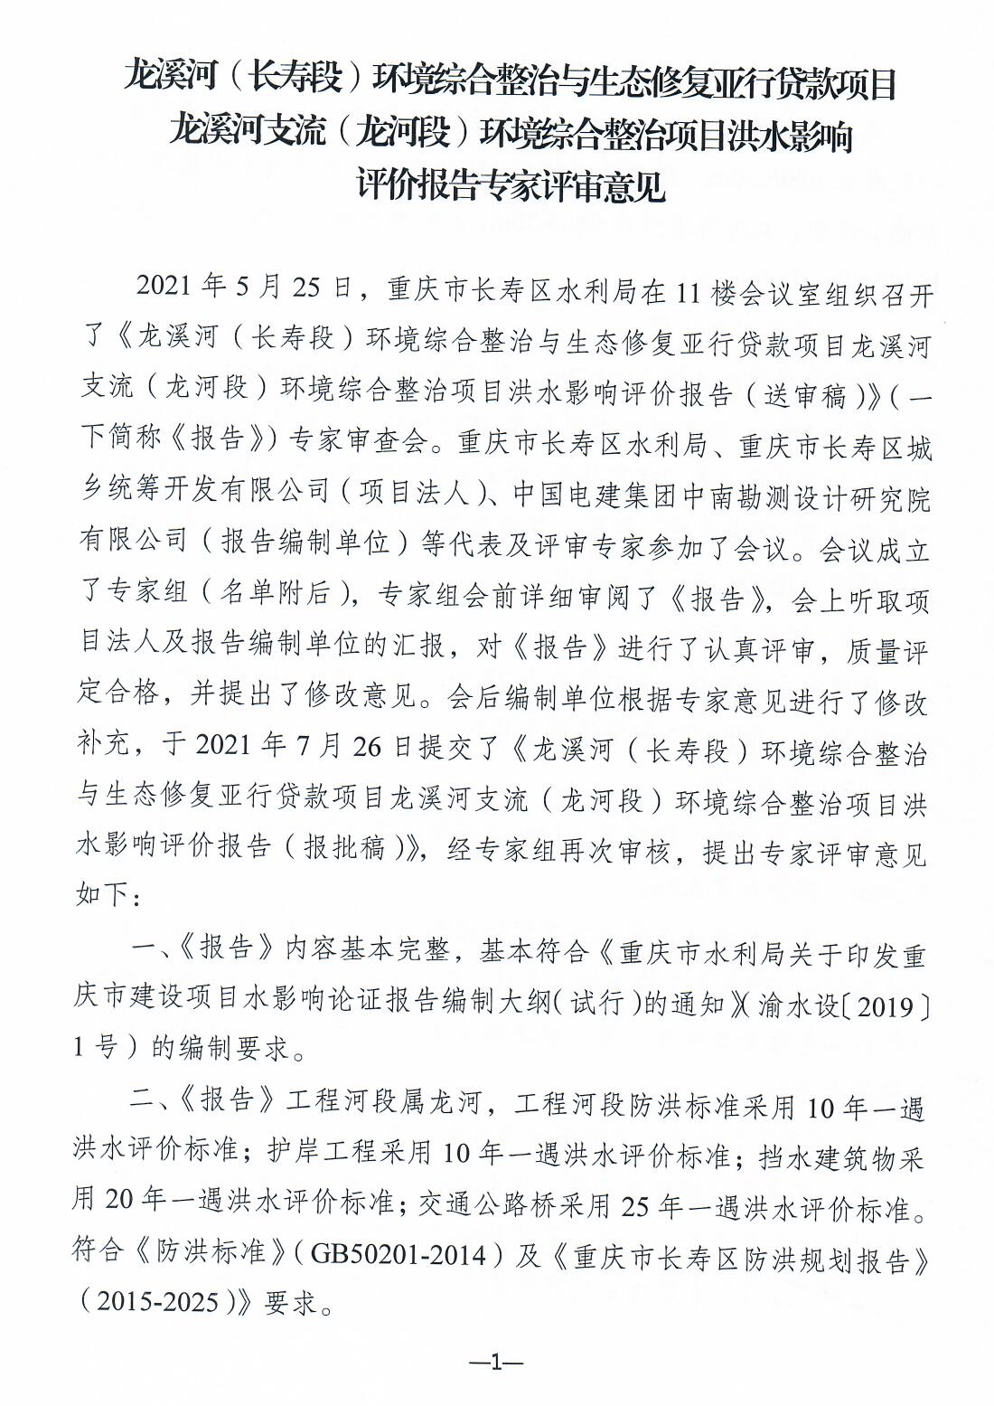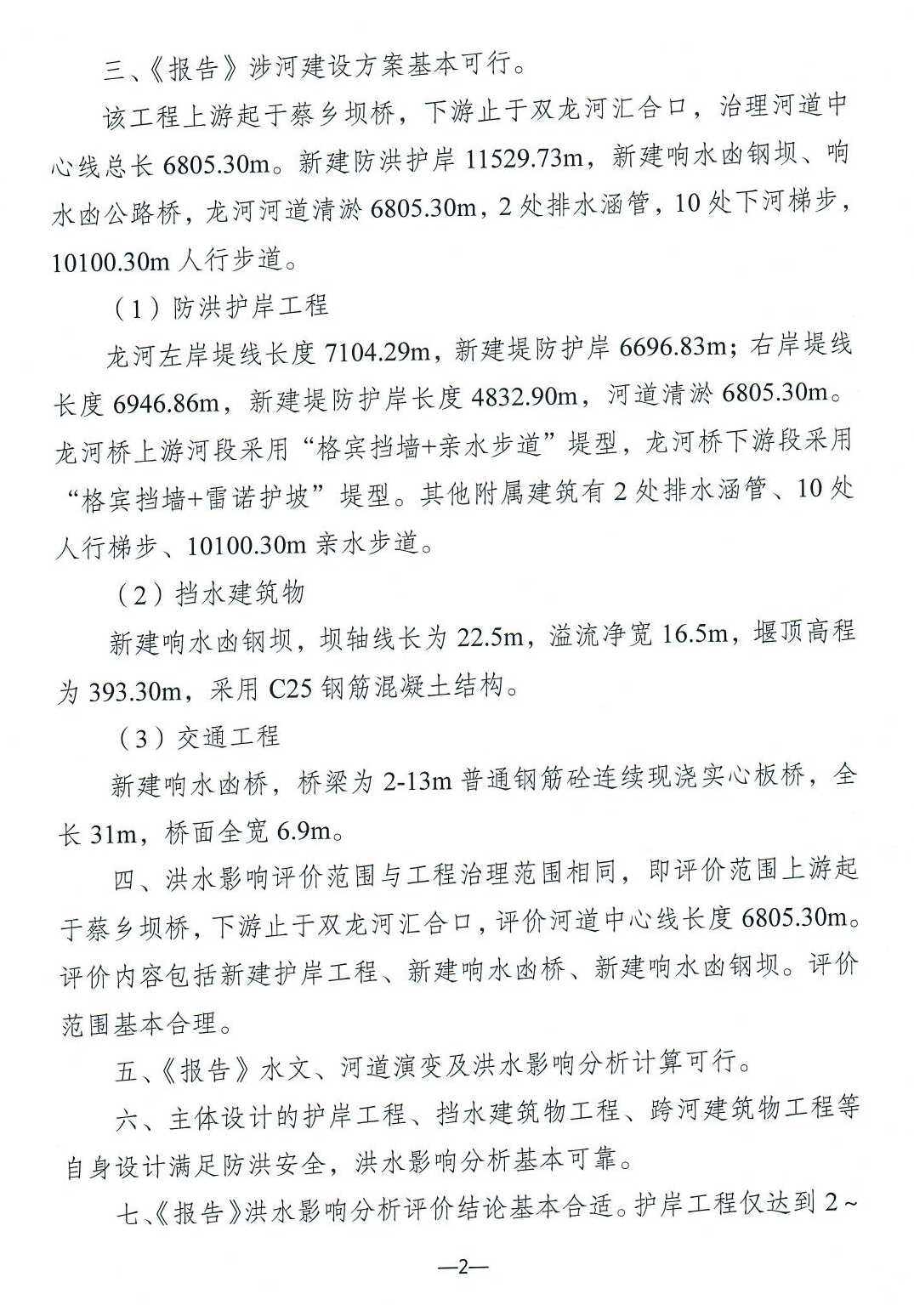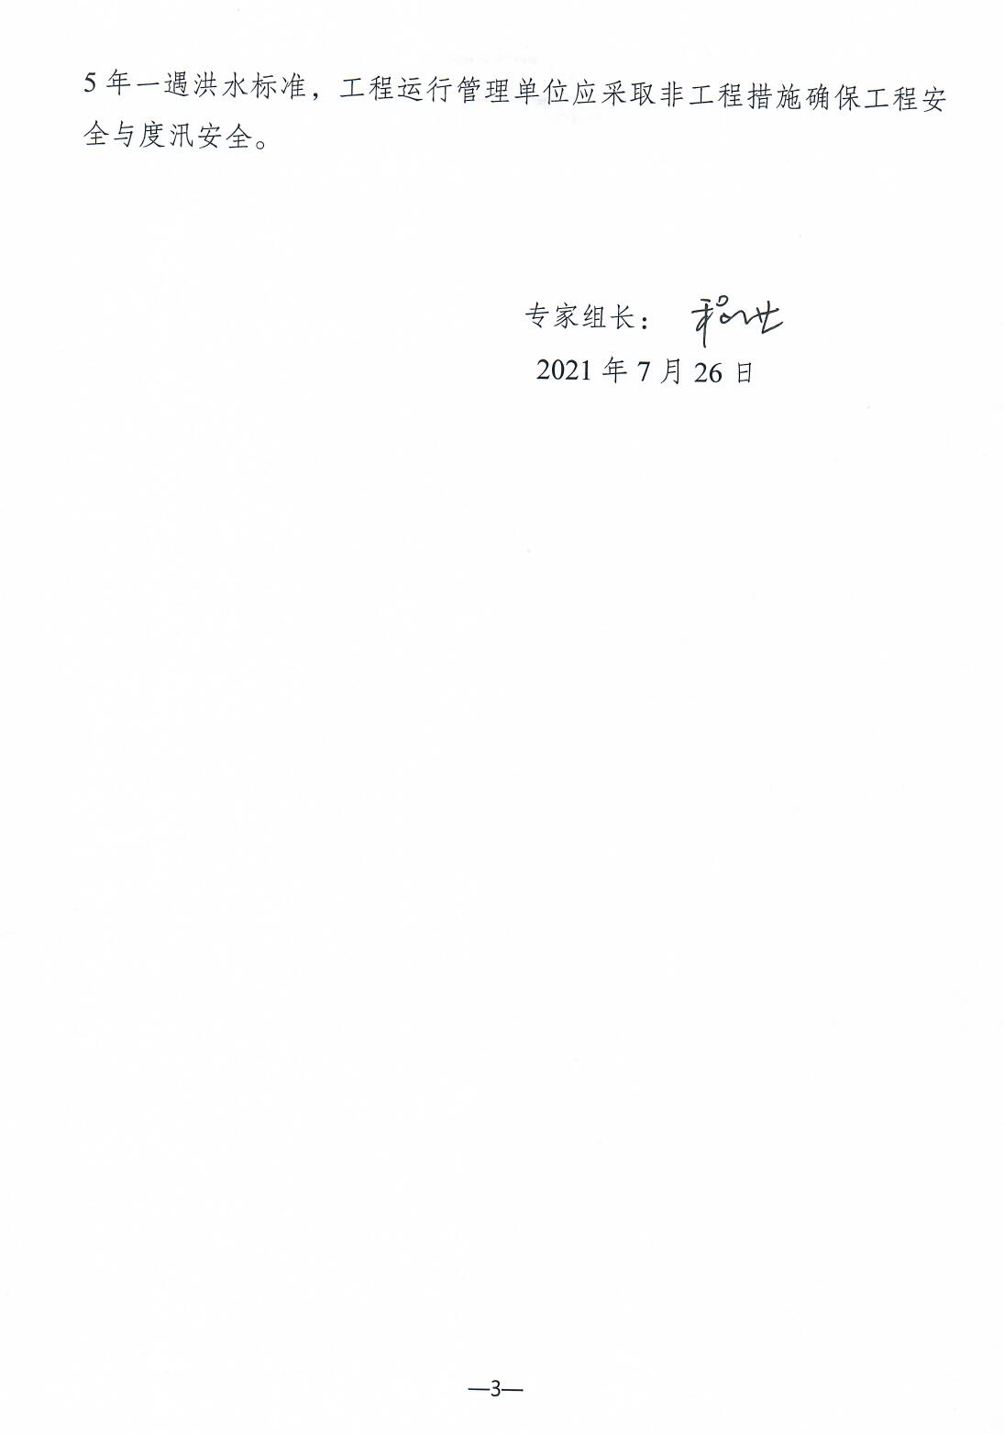

重庆市长寿区水利局办公室 2021年9月22日印发

